Final Report

# INTRODUCTION

## Project Overview

**SB Works** is a MERN-stack freelancing platform that connects clients with skilled freelancers. It provides an intuitive interface for posting projects, bidding, communication, and submitting completed work. The platform is secured and monitored by an admin team to ensure smooth communication and quality assurance.

## Purpose

SB Works aims to solve the issues present in conventional freelancing platforms such as poor user interface, communication gaps, and lack of transparency. It empowers freelancers to build portfolios and connect with clients efficiently while ensuring a seamless hiring process for clients.

# IDEATION PHASE

## Problem Statement

Current freelancing platforms lack real-time communication, proper admin supervision, and secure workflow. This leads to miscommunication, payment issues, and inconsistent project quality.

## Empathy Map Canvas

**Users:** Freelancers and Clients

* + - **Think & Feel:** Desire reliability, smooth project handling, and recognition
    - **See:** Confusing interfaces, unfair reviews, trust issues
    - **Hear:** Complaints about fake profiles, ghosting, payment issues
    - **Say & Do:** Ask for professionalism, security, transparency
    - **Pain:** Lack of admin control, delayed payments, fake projects
    - **Gain:** Trust, visibility, quality work, good feedback loop

## Brainstorming

* + - Secure user authentication
    - Simple project bidding system
    - Integrated real-time chat
    - Admin dashboard for platform monitoring
    - Reviews and rating mechanisms
    - Email notifications and alerts

# REQUIREMENT ANALYSIS

## Customer Journey Map

1. Client registers/login
2. Posts a project with details
3. Freelancer views project and bids
4. Client selects suitable freelancer
5. Work is submitted and reviewed
6. Feedback is shared
7. Admin resolves disputes and ensures integrity

## Solution Requirement

* + - Authentication system (JWT)
    - Chat system
    - Dashboard for admins, freelancers, and clients
    - MongoDB database integration
    - Responsive design using Material UI/Bootstrap

## Data Flow Diagram

**Frontend (React)** → **Backend (Express API)** → **MongoDB**

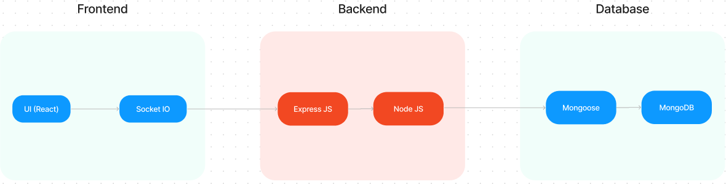

Users interact via the frontend which communicates with the backend using Axios and RESTful APIs. The backend fetches/stores data in MongoDB.

## Technology Stack

* + - **Frontend:** React.js, Axios, Bootstrap, Material UI
    - **Backend:** Node.js, Express.js
    - **Database:** MongoDB with Mongoose
    - **Authentication:** JWT
    - **Version Control:** Git, GitHub

# PROJECT DESIGN

## Problem-Solution Fit

The system resolves major freelancing problems through a scalable and interactive application that facilitates seamless project handling and admin-monitored transactions.

## Proposed Solution

A secure, real-time, and user-friendly freelancing platform that enables project posting, bidding, communication, and submission under admin supervision.

## Solution Architecture

* + - React for frontend and user interface
    - Express handles server-side logic and APIs
    - MongoDB stores user data, project details, and chat history
    - Admin panel built into backend for platform control

# PROJECT PLANNING & SCHEDULING

* 1. **Project Planning**

|  |  |
| --- | --- |
| **Milestone** | **Activities** |
| M1 | Project folder setup, environment configuration |
| M2 | Backend API development |
| M3 | MongoDB schema and models setup |
| M4 | Frontend development with React |
| M5 | UI testing and backend integration |
| M6 | Final testing, bug fixing, and deployment |

# FUNCTIONAL AND PERFORMANCE TESTING

## Performance Testing

* + - Backend endpoints were tested using Postman for load and performance
    - React components rendered under 200ms locally
    - Chat and authentication tested under simulated concurrent users
    - API response time consistently < 500ms

# RESULTS

* 1. **ER Diagrams :**

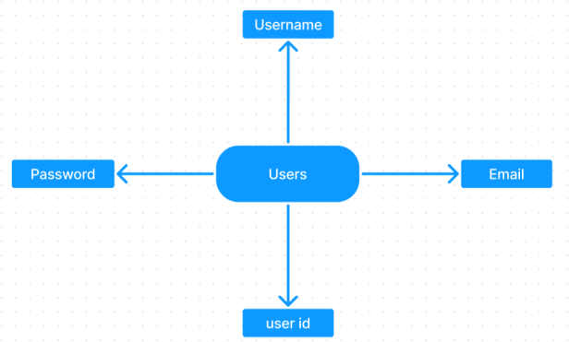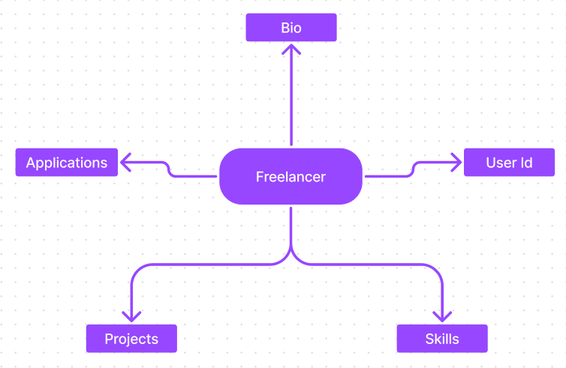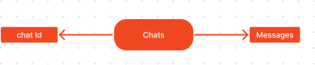

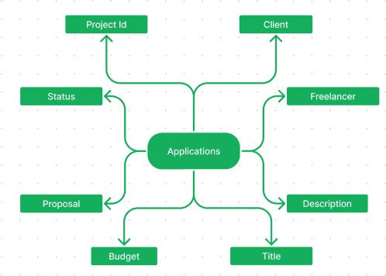

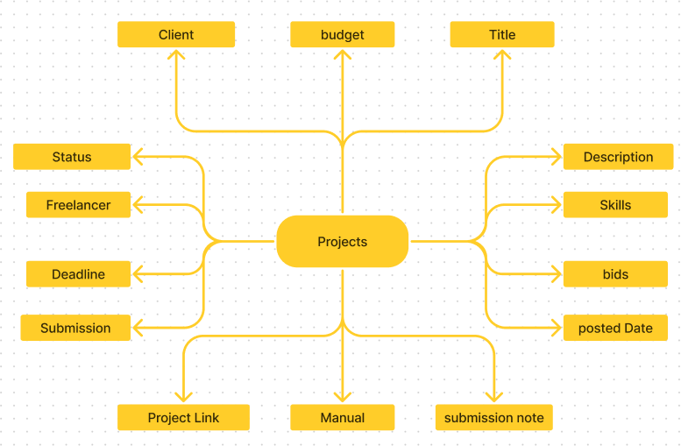

SB Works connects clients with skilled freelancers through a user-friendly platform. Clients can post projects with details and browse freelancer profiles to find the perfect match.

Freelancers can submit proposals, collaborate with clients through secure chat, and securely submit work for review and payment. An admin team ensures quality and communication, making SB Works a go-to platform for both clients and freelancers.

## Output Screenshots

* + - Landing Page

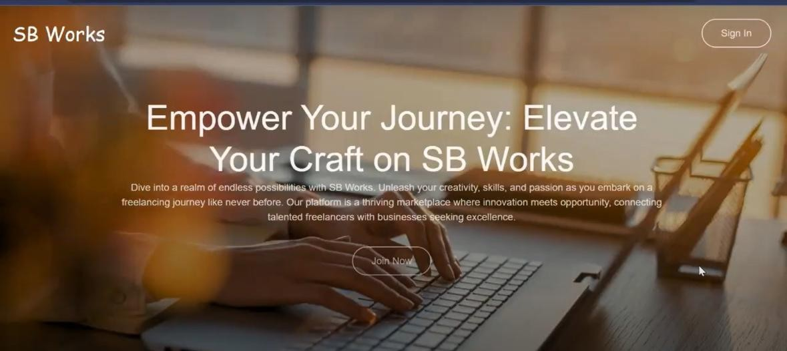

* + - Signup/Login Pages

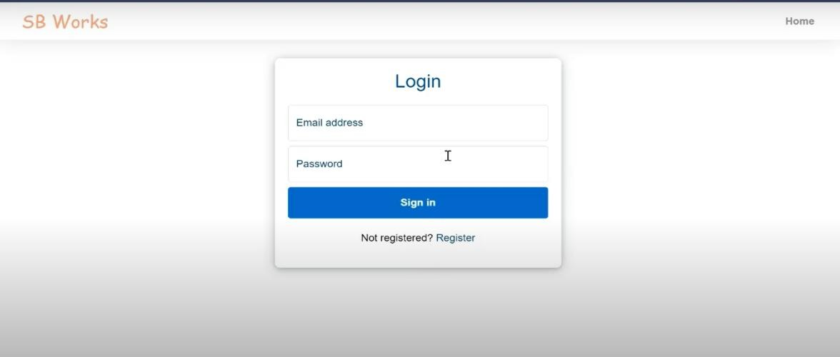

* + - Freelancer Dashboard

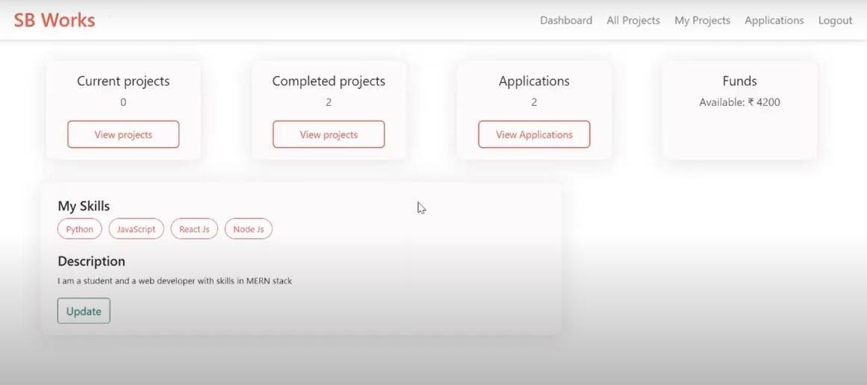

**Admin dashboard:**

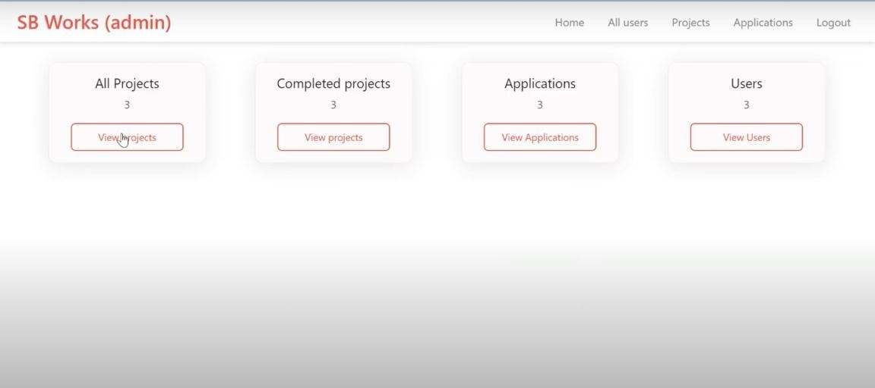

**All projects:**

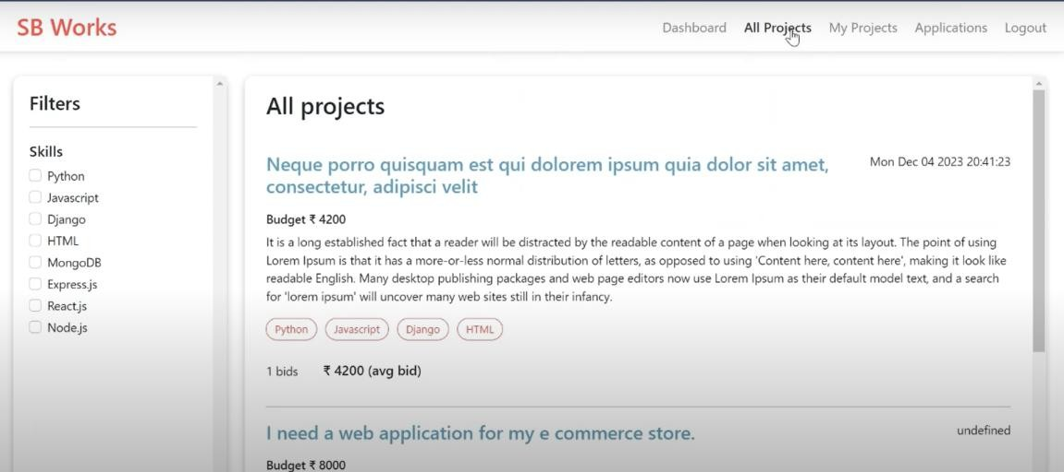

**Freelance projects:**

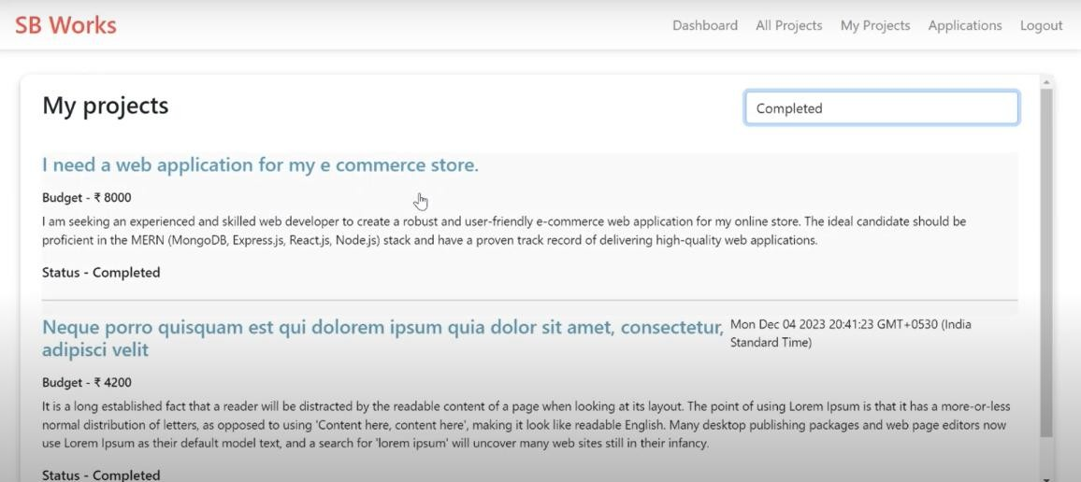

**Applications:**

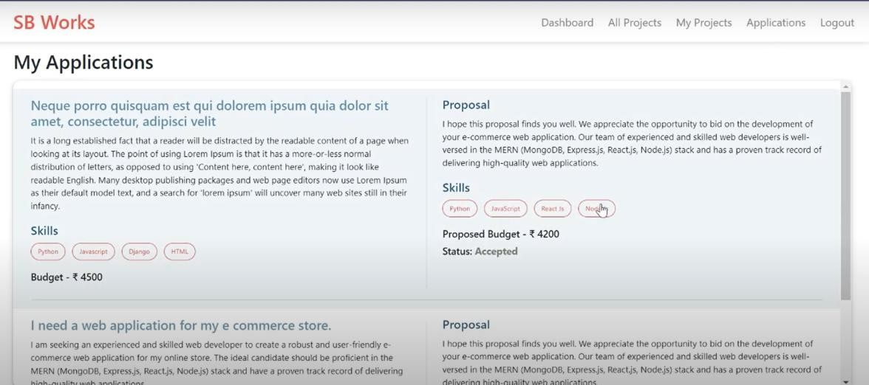

**New project:**

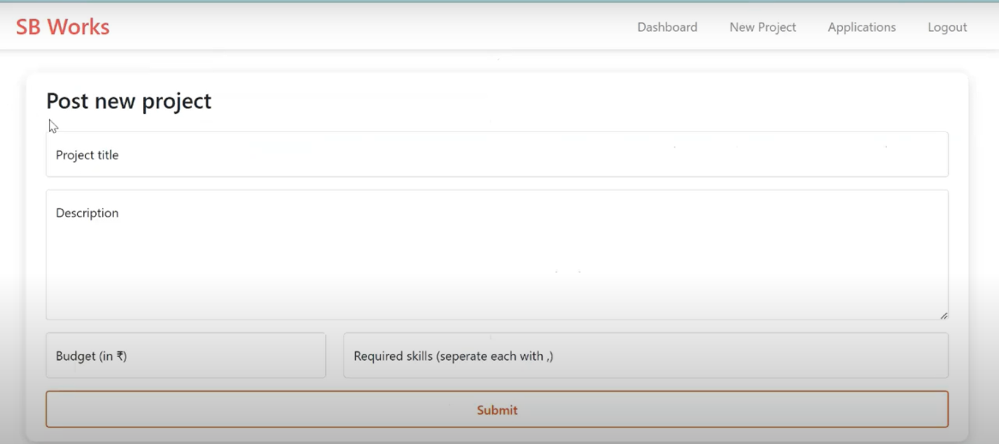

# ADVANTAGES & DISADVANTAGES

## Advantages

* Clean and responsive interface
* Real-time communication system
* Admin dashboard ensures integrity
* Reusable code and scalable backend
* Secure authentication

## Disadvantages

* No mobile app yet
* No inbuilt payment gateway
* Limited analytics and reporting tools
* Admin role still basic and needs advanced filters

# CONCLUSION

SB Works is a well-designed freelancing application tailored for today's digital talent economy. It simplifies the freelancing experience for clients and freelancers alike, offering real-time tools, transparency, and structure for professional collaboration.

# FUTURE SCOPE

* Mobile app for Android and iOS
* Integration with payment gateways (Razorpay/Stripe)
* Chatbot support for admin and client
* AI-based freelancer-client matching
* Advanced analytics dashboard for admins
* Push notifications and multilingual support

# APPENDIX

* **GitHub Repository:**

<https://github.com/syedmuskan122/FreelanceFinder-Discovery-Opportunitites-Unlocking-Potential>

* **Project Demo and Code Folder:**

<https://drive.google.com/drive/folders/13mAJ8Ax5aiApzGqMtqvp41uao8ZAl1g1>

* **Dataset:** Not applicable
* **Tools Used:** VS Code, MongoDB Atlas, Postman, GitHub